Patch may boost repair after heart attack
By Smitha MundasadHealth reporter, BBC News 16 September 2015

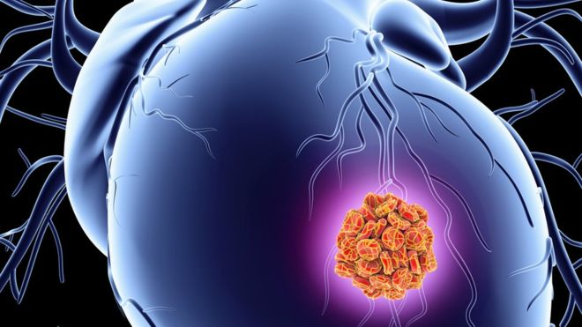
During a heart attack, heart muscle cells die because of a lack of oxygen
A prototype patch could help the repair the damage caused by a heart attack, scientists say.
The early work, carried out on mice and pigs, reveals the protein-infused patch encourages the growth of healthy cells and leads to less scarring.
Scarring can be common after a heart attack, making the heart pump less effectively and sometimes fail.
Writing in the journal Nature, researchers say the patch may one day revolutionise treatment.
During an attack, muscle cells in the heart die because of a lack of blood flow and scientists believe repairing or replacing some of these cells may help reduce long-term damage.
In this trial an international team of researchers soaked a collagen patch in a protein known as Fstl1 and stitched it on to the hearts of animals who had experienced heart attacks.
Though the protein occurs naturally in healthy hearts, it becomes depleted in a key layer of the heart after an attack.
Two weeks later the hearts began to grow fresh muscle cells and new blood vessels, while showing signs of pumping more effectively.
Prof Pilar Ruiz-Lozano at Stanford University (which has patented the patch), said: "Many were so sick prior to getting the patch that they would have been candidates for heart transplantation.
"The hope is that a similar procedure could eventually be used in human heart attack patients who suffer severe heart damage."
Commenting on the study in Nature, Prof Gordana Vunjak-Novakovic at Columbia University, said the work "could lead to entirely new modalities for treating heart infarction".
But she cautioned that further studies needed to be done to understand whether this type of approach would work on larger animals and ultimately humans.

